Phase I
Step 1: Scan Open ports on Metasploitable3
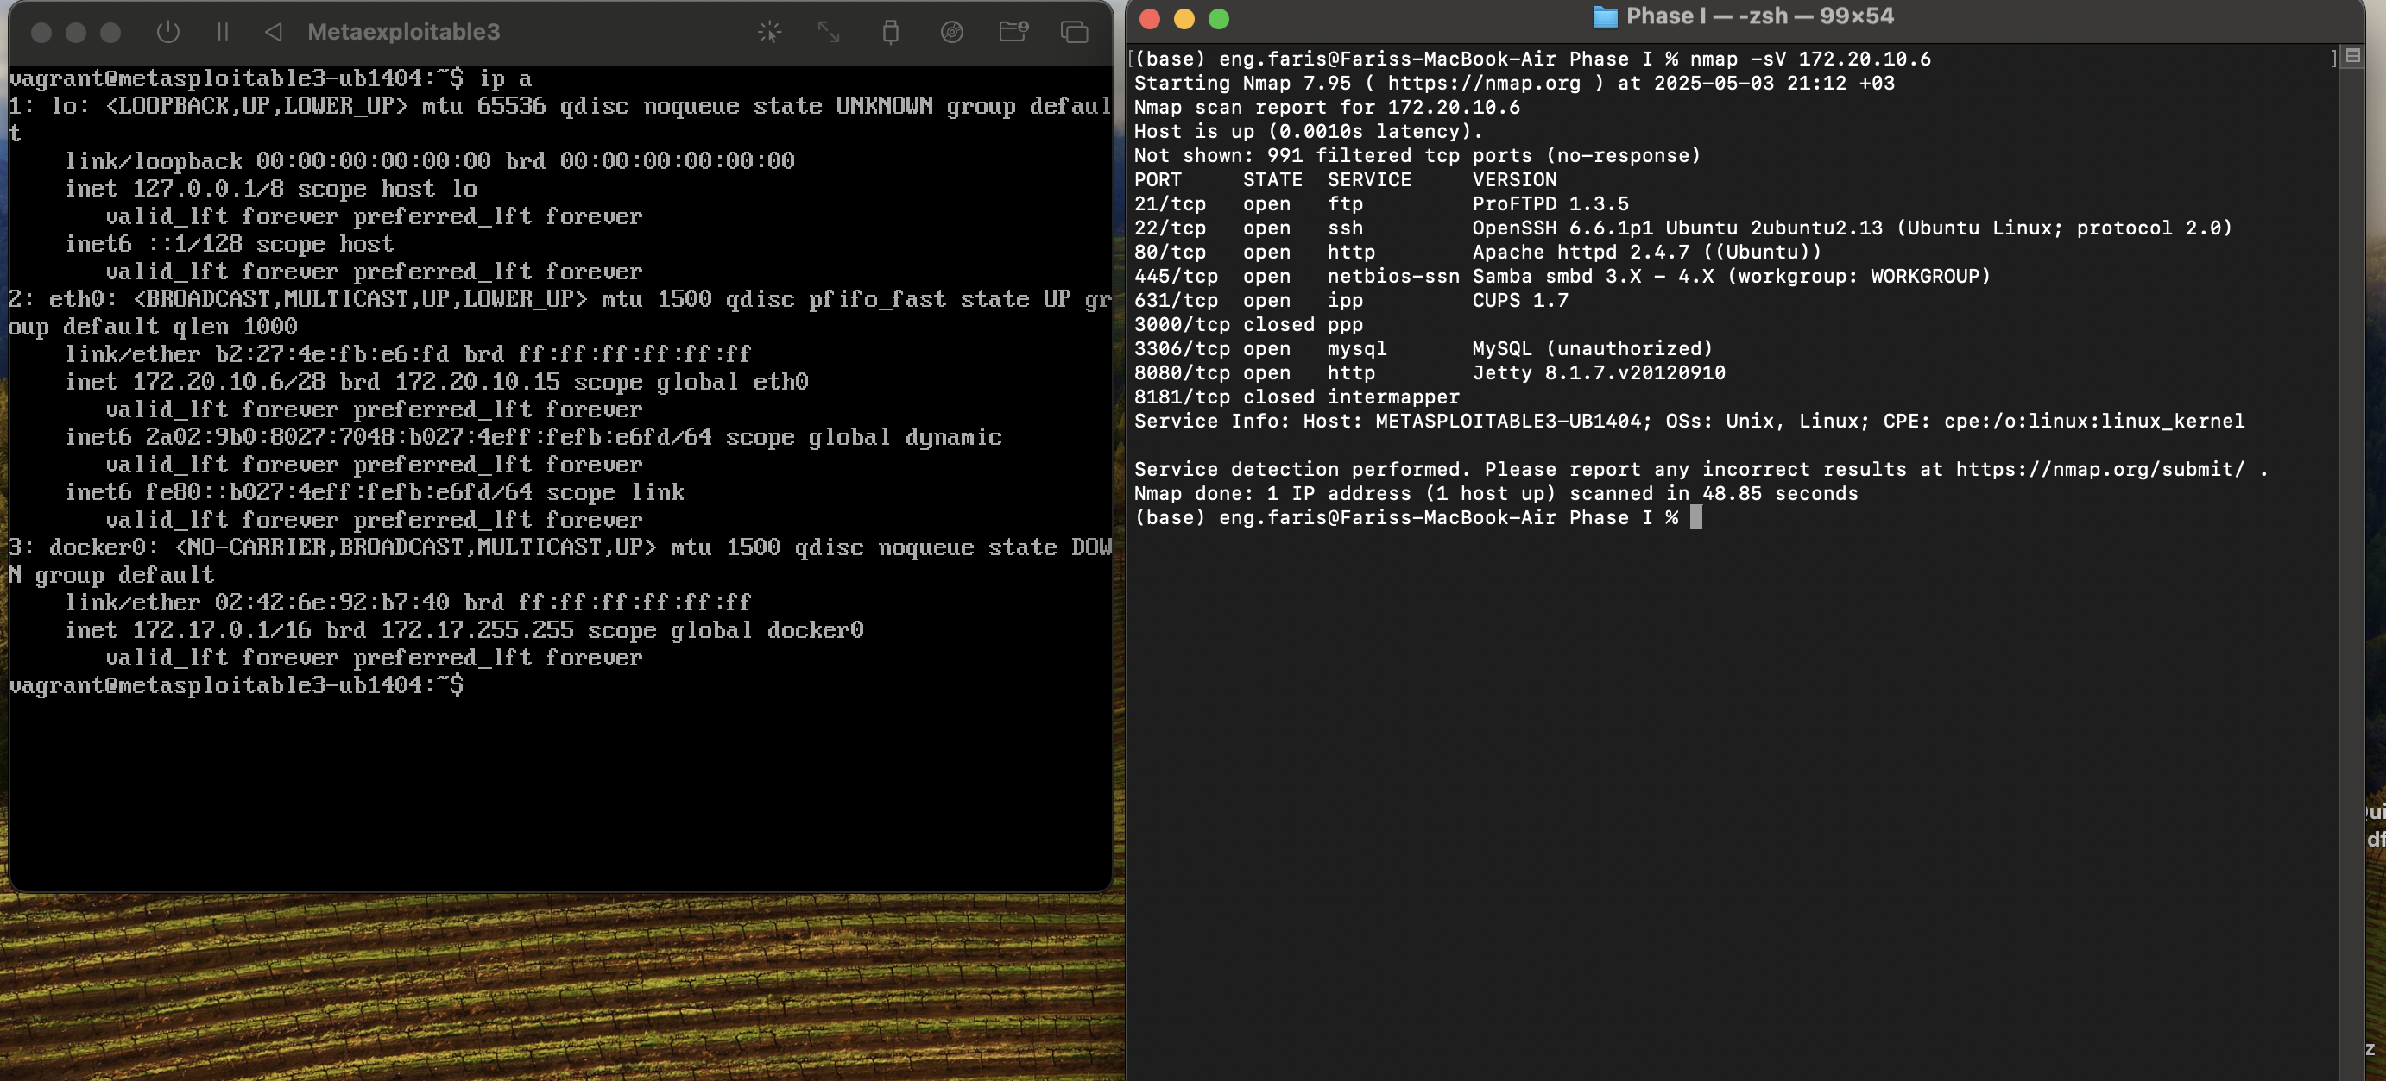
As you can see in the image above, port 21 is open so in this phase we will target ProFTPD 1.3.5.
Step 2: Manual exploitation of ProFTPD 1.3.5 using Metasploit.
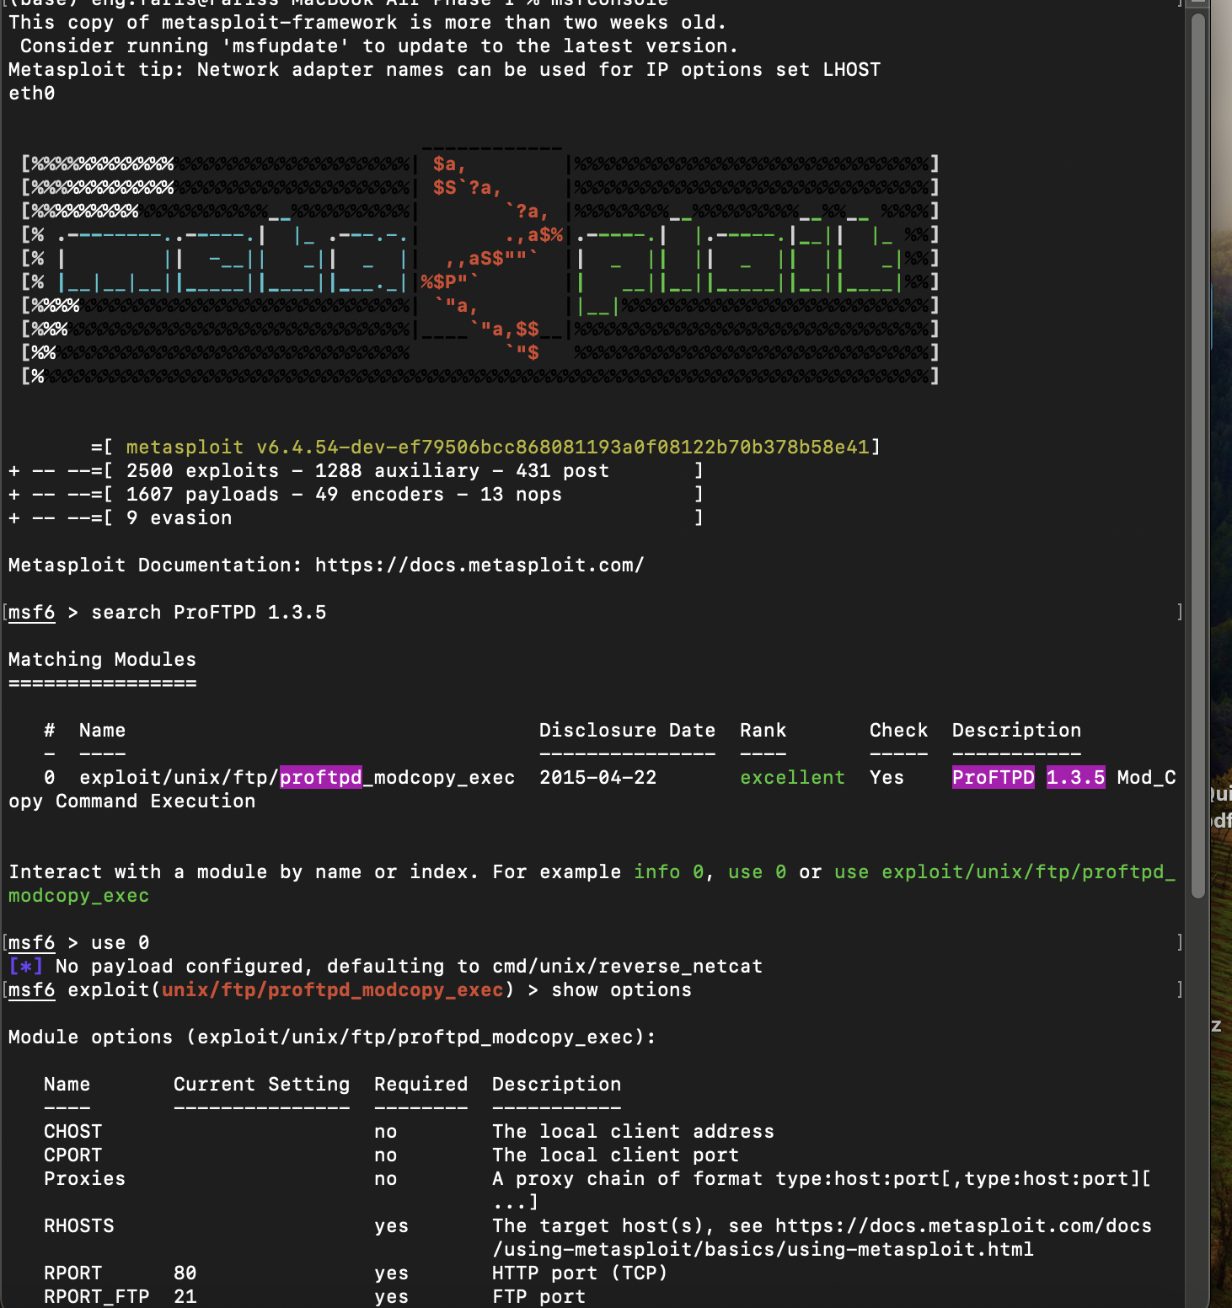
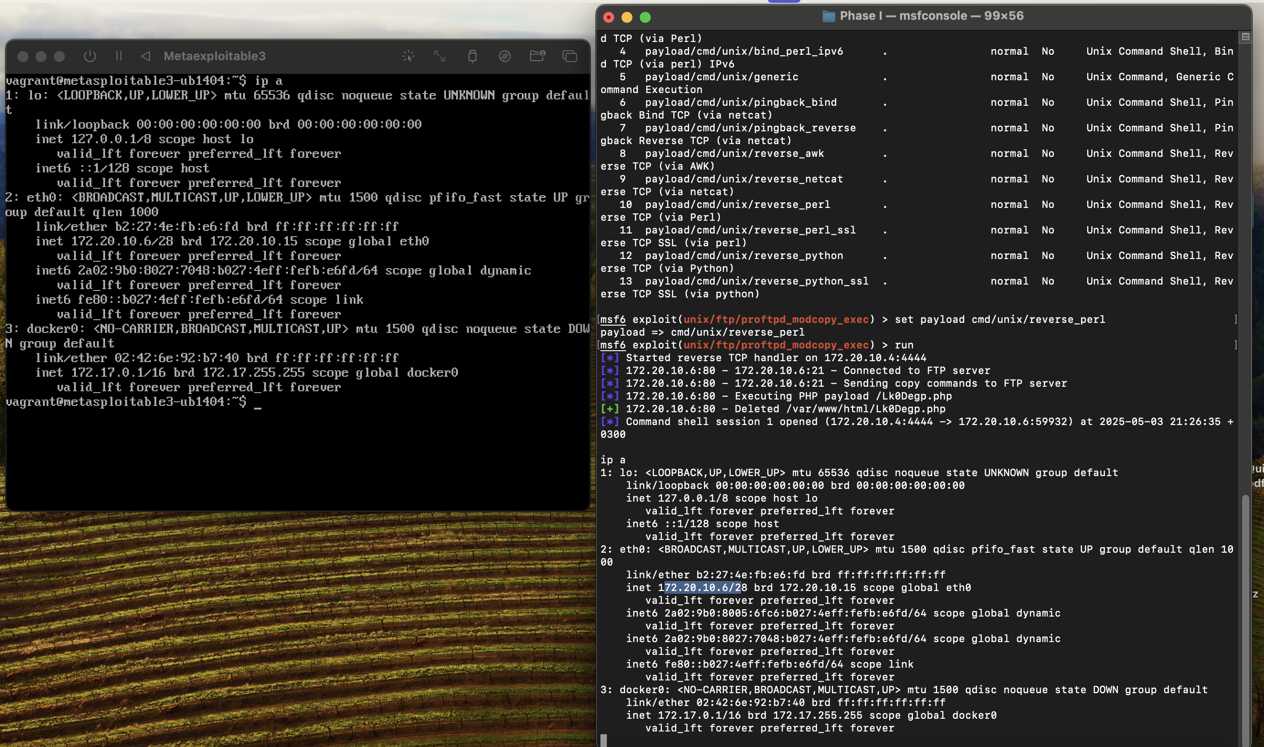
As we can see, we were able to remotely access the Metasploitable3 and run the ip a command to verify that the access was successful.
Step 3: Automated exploitation of ProFTPD 1.3.5 using Metasploit.
- We use a Python script to target ProFTPD 1.3.5 to remotely exploit it and gain access to the Metaexploitable3
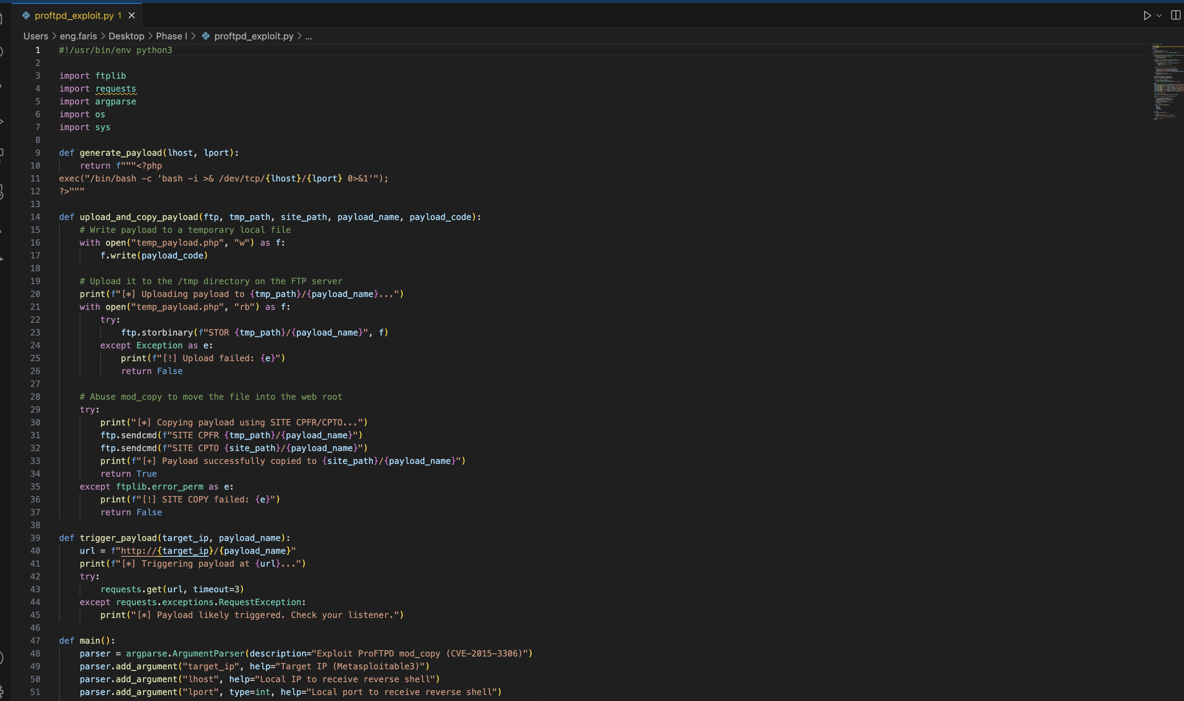
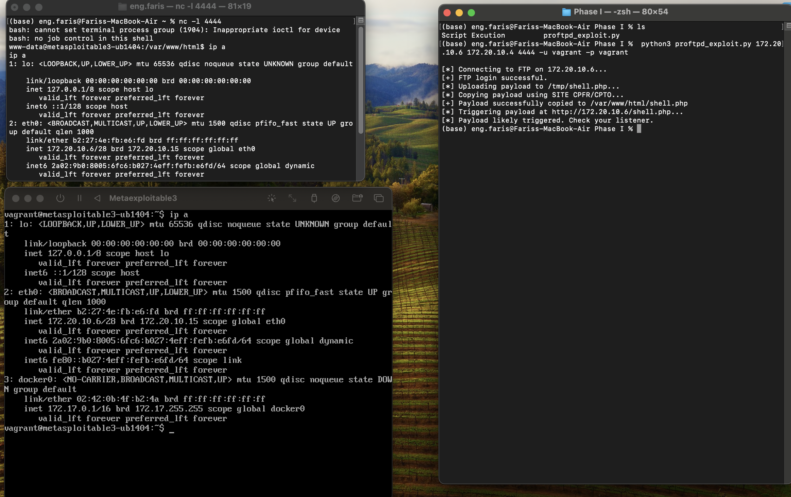
As we can see in the above images, by executing the Python script in one shell and listening on the other shell, we were able to gain remote access to the machine and executed the command ip a to validate the success of the exploitation.

